# How to play

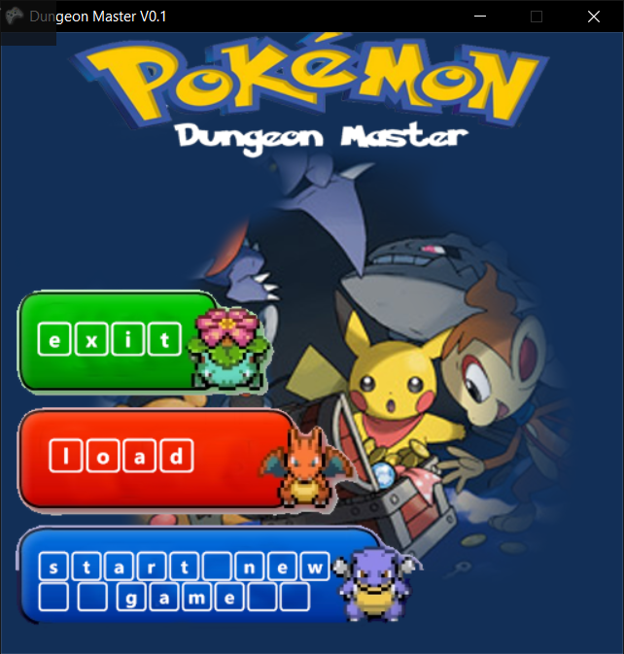

At this screen

* Press 1 to exit
* Press 2 to load a new game
* Press 3 to start a new game

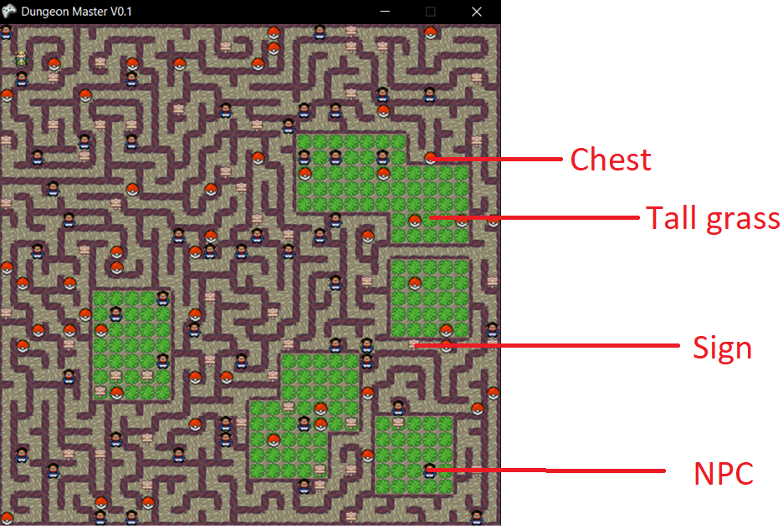

At this screen

* Use the WASD keys for movement
* Press E to open a menu
* Use the arrow keys to navigate menus
* Press Enter key to select an option
* Press E to Exit the current menu
* When on top of a Sign/Chest Press T to interact, press T to exit GUI
* When on top of NPC press T to start a battle

# Required files

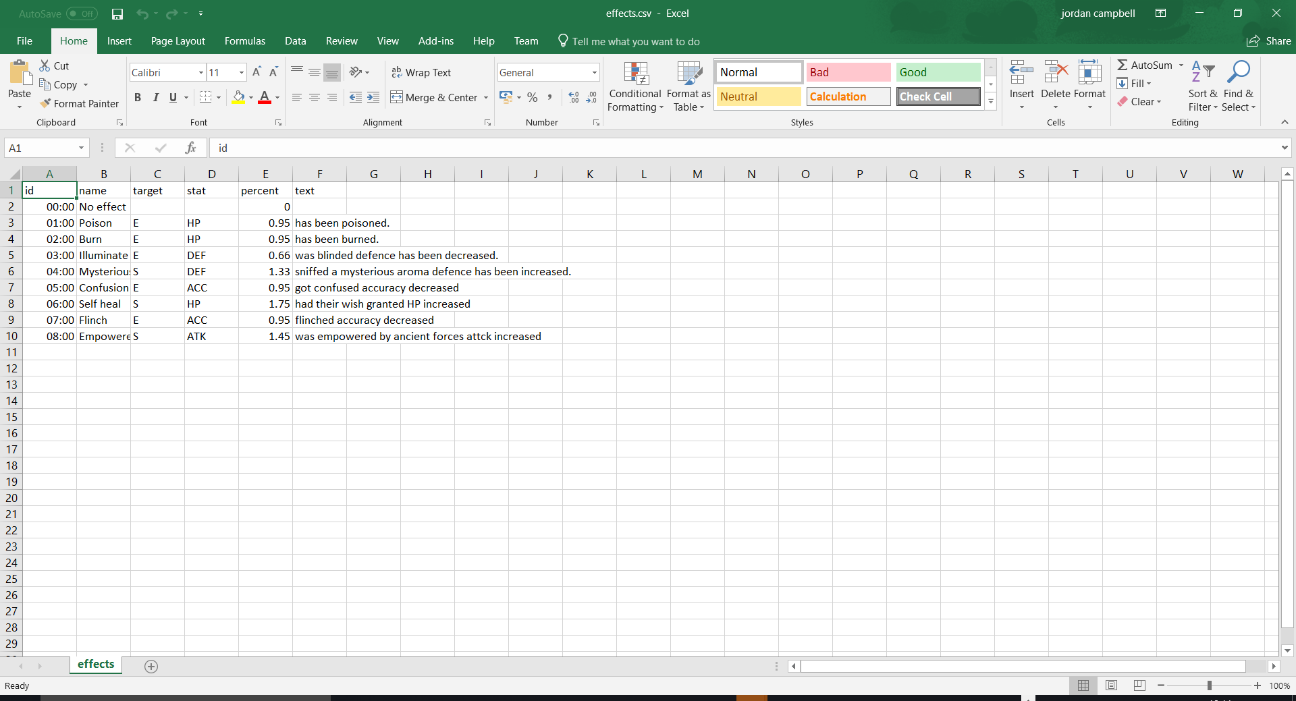

Stores the data for effects used by moves.

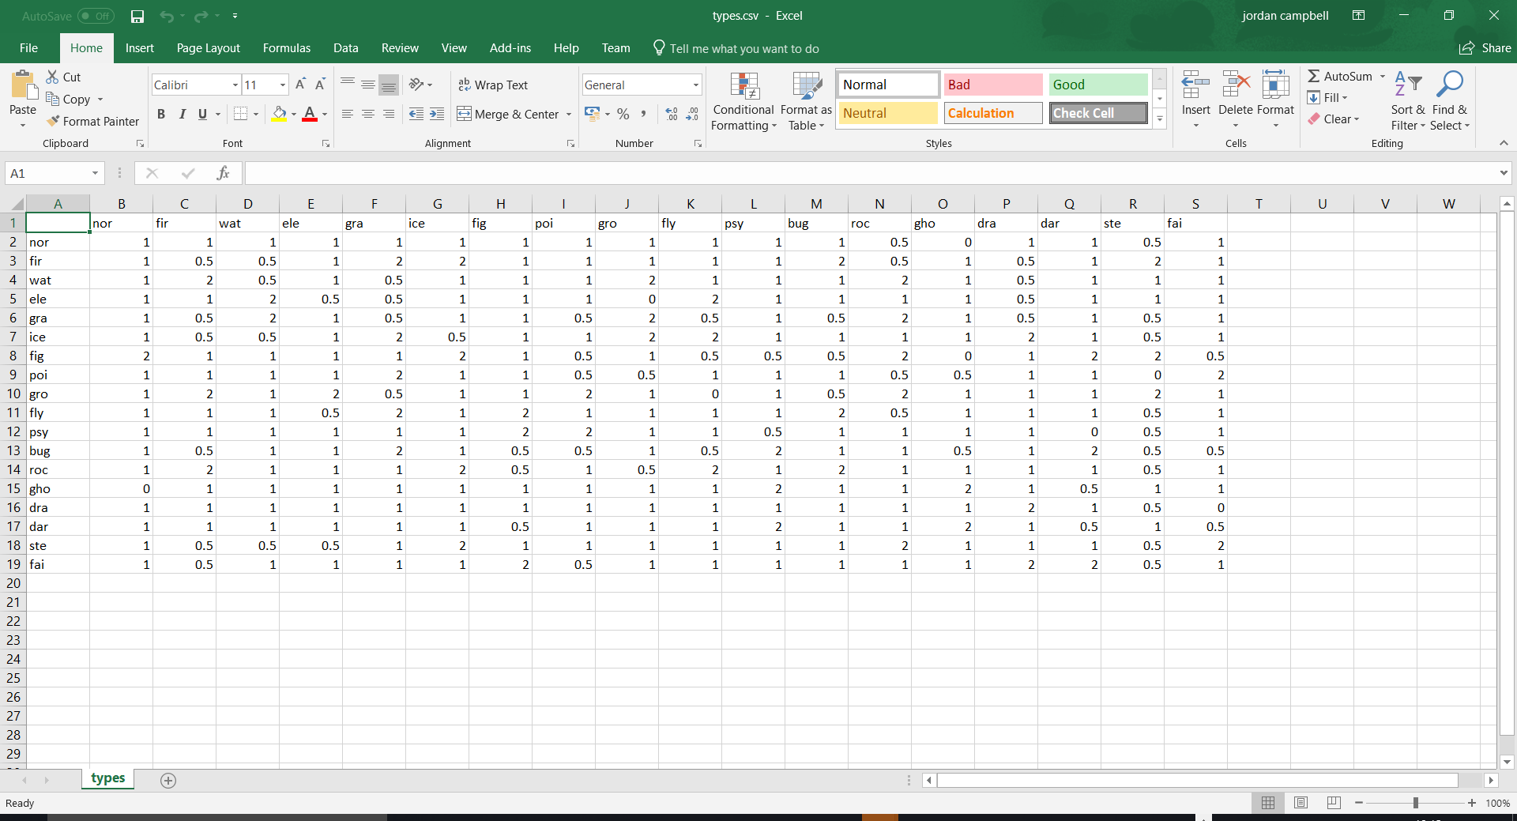

Stores the effectiveness multipliers. With the attacking type going down and the defending type across.

